Did your NC House and Senate Members vote to expand private school vouchers by hundreds of millions of dollars in September?

**NC House of Representatives**

**View an** [**interactive map here**](https://www.datawrapper.de/_/NKuwc/?v=2) **to see the names of representative and district numbers.**

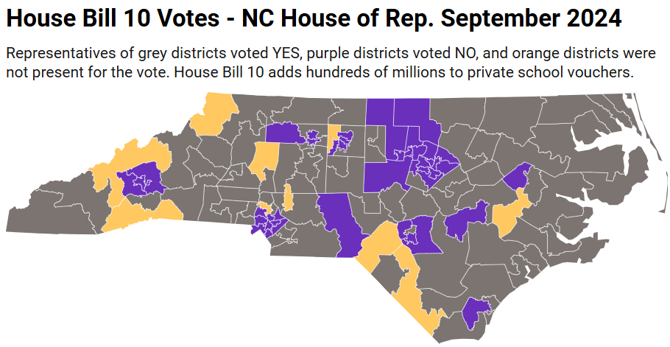

**NC Senate**

**View an** [**interactive map here**](https://www.datawrapper.de/_/NKuwc/?v=2) **to see the names of senators and district numbers.**

